Pandamonium

Panda Bowmen
West Park Leeds RUFC
The Sycamores,
Bramhope,
Leeds, LS16 9JR
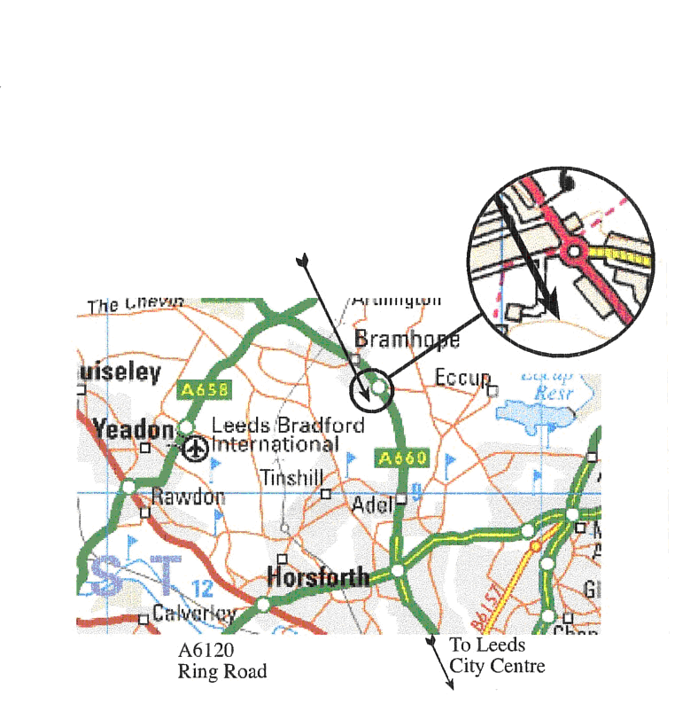

Saturday 17th May 2025

Assembly 11.00am

Directions:
If coming from the south on the A660 Leeds Road, pass Golden Acre Park, at the roundabout turn left into The Sycamores, then immediate left into the Rugby Grounds



Pandamonium

29th Longbow Tournament

Panda Bowmen
West Park Leeds RUFC
The Sycamores, Bramhope, Leeds, LS16 9JR

Saturday 17 th May 2025

Assembly 11.00am
Refreshments available

A Western Round Will Be Shot

Lady Paramount: TBA
Judges: TBA

Panda Bowmen

Pandamonium – 17th May 2025
Name: Mr/Mrs/Miss/Mst
Address:
Post Code: Phone No:
E-mail address:
Club: ArcheryGB No:
Junior Age: Results sheet via e-mail? Yes/No
I understand that details will be stored and used to inform me of future events organised by Panda Bowmen
Signed:
Name: Mr/Mrs/Miss/Mst
Address:
Post Code: Phone No:
E-mail address:
Club: ArcheryGB No:
Junior Age: Results sheet via e-mail?
I understand that details will be stored and used to inform me of future events organised by Panda Bowmen
Signed:
Entry fee: £8.00 per person
Payment by BACS. Please use your name on payment.
Panda Bowmen sort code: 30-99-50 Acct No: 55509562
Cheques made payable to: Panda Bowmen please email tournaments@panda-bowmen.co.uk.
Email entries to: tournaments@panda-bowmen.co.uk

Panda Bowmen

Pandamonium – 17th May 2025

A Western Round will be shot

Regulations:
- Dress Regulations will be observed.
- Trophies will be held for one year and returned at or before the next tournament.
- An interval will be held at the end of the first 4 dozen arrows.
- Only wooden bows and arrows will be allowed.
- Sherry will be served during the shoot.
- Dogs are not allowed in the Rugby Club grounds.
- Refreshments will be available to purchase.

The Shoot will end with an Agincourt Volley

Entry fee: £8.00
Payment by BACS. Please use your name on payment.
Panda Bowmen sort code: 30-99-50 Acct No: 55509562
New bank details since last year

Entries cannot be accepted without the archer’s signature (parent or guardian’s signature for juniors) and an ArcheryGB number. Please note that you are signing to confirm that you are a current ArcheryGB member and agree to abide by BLBS Rules.

If you require a results sheet via e-mail then please ensure your e-mail address is completed, and readable, on the entry form.

Please Note
In accordance with AGB Child Protection & Vulnerable Adults guidelines, all persons wishing to use any type of photography must register their interest with the event organizer on the day of the event.
Details will be stored and used to inform entrants of future events organised by Panda Bowmen

